Meets ASE Task: (A7-D-3) P-1 Inspect and test HVAC system blower motors, resistors, switches, relays, wiring, and protection devices; determine needed action.
Name:_____________________________________
Date:_____________
Time on Task:_____________
Make/Model/Year:____________________________________
VIN:_________________________________
Evaluation (Enter number from 4, 3, 2, 1) :_________
Blower Motor Circuit
Page 189
1. Check service information and determine the specified testing procedures.
__________________________________________________________________
__________________________________________________________________

2. Locate the blower motor schematic and determine the following information:
a. Describe the blower location ___________________________________________
b. Is the blower motor accessible from inside the vehicle or from under the hood?
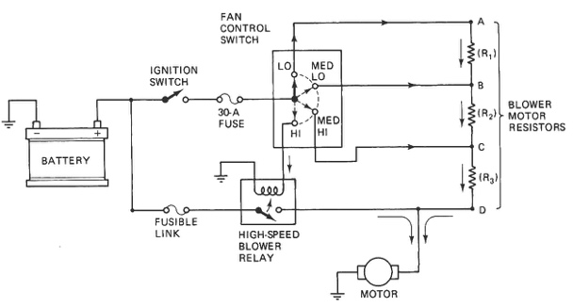
______________________________
c. List the wire colors and their gauge:
Power = _________________
Ground = ________________
3. How are the various speeds controlled?
Resistor pack
Electronic controller
Other (describe)_______________
4. What fuse number (label) and amperage rating are used for the blower motor?
a. Fuse number (label) ________________________________
b. Fuse rating _______________________________
5. Describe the location of the ground(s) for the blower motor circuit. ______________
________________________________________________________________
6. Measure the current draw of the blower motor on high speed.
Amperage = __________ (normal blower motor amperage draw is about 12-14
amperes)
7. Based on the inspection and test results, what is the needed action? ______________
_________________________________________________________________

