Meets ASE Task: (Not specified by ASE)
Name:_____________________________________
Date:_____________
Time on Task:_____________
Make/Model/Year:____________________________________
VIN:_________________________________
Evaluation (Enter number from 4, 3, 2, 1) :_________
Hybrid Vehicle A/C System Precautions
Page 188
1. Check service information for the vehicle manufacturer’s specified safety precautions
regarding the A/C system electrical circuits, safety, and service.

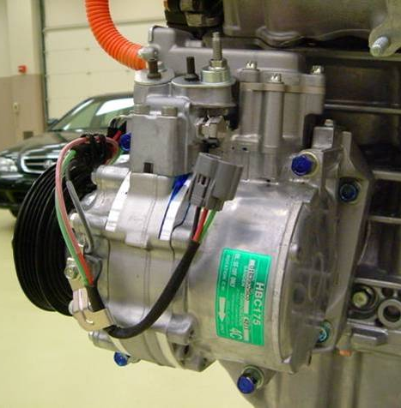
A. Electrical circuit precautions:

___________________________________

___________________________________

___________________________________

___________________________________

___________________________________

B. Safety precautions: _____________________________________________

__________________________________________________________

__________________________________________________________

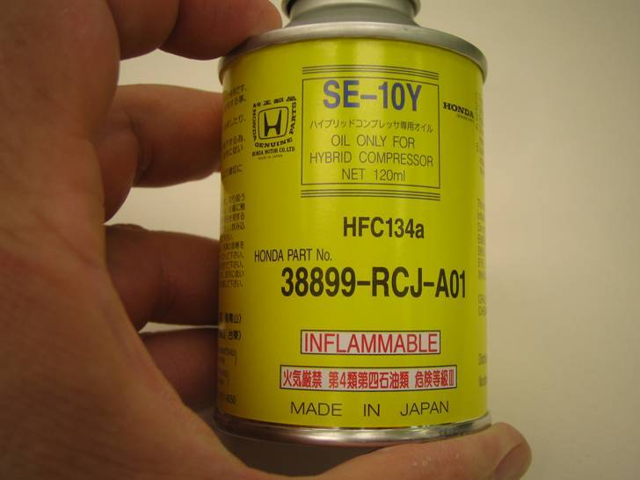
C. Service precautions: ______________________

____________________________________

____________________________________

____________________________________

____________________________________

____________________________________

