Meets ASE Task: (A7-A-2) P-1 Identify heating, ventilation, and air conditioning (HVAC) components and configurations.
Name:_____________________________________
Date:_____________
Time on Task:_____________
Make/Model/Year:____________________________________
VIN:_________________________________
Evaluation (Enter number from 4, 3, 2, 1) :_________
A/C Component Identification
Page 187
1. Locate the air-conditioning system label. Describe the location.
______________________________________________________________
2. According to the label, what type of refrigerant is used in the vehicle?
HFC-134a (R-134a or SUVA®)
CFC-12 (R-12 or Freon®)
R1234yf
3. According to the label, what is the capacity of the system? ____ ounces
4. Describe the location of the compressor _________________________________
______________________________________________________________
5. Describe the location of the condenser __________________________________
______________________________________________________________
6. Describe the location of the evaporator __________________________________
______________________________________________________________
7. Describe the location of the accumulator or receiver-drier ___________________
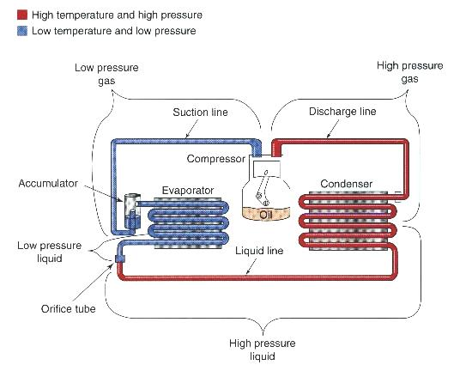
______________________________________________________________
8. Does the system use an expansion valve?
Yes No
9. Does the system use an orifice tube?
Yes No

