Meets ASE Task: (A6-G-7) P-1 Diagnose operation of safety systems and related circuits (such as: horn, airbags, seat belt pretensioners, occupancy classification, wipers, washers, speed control/collision avoidance, heads-up display, parking assist, and back-up camera); determine needed action.
Name:_____________________________________
Date:_____________
Time on Task:_____________
Make/Model/Year:____________________________________
VIN:_________________________________
Evaluation (Enter number from 4, 3, 2, 1) :_________
Automated and Connected Vehicle ID
Page 185
1. Check service information for the type of system that the vehicle uses to communicate
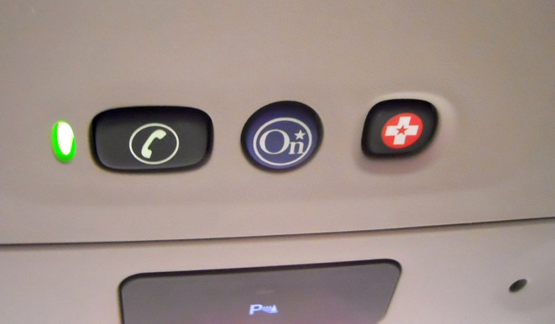
with the outside world. Check all that apply.
On-Star or similar
Wi-fi hot spot
Vehicle-to-vehicle communication
Vehicle-to-internet
Other (describe)_________________
______________________________
2. With what automated features is the vehicle equipped? Check all that apply.
Radar cruise control
Auto pilot or Super Cruise
Lane keep assist
Self-parking
Other (describe) ________________________________________________
