Meets ASE Task: (A6-G-4) P-1 Describe disabling and enabling procedures for supplemental restraint system (SRS); verify indicator lamp operation.
Name:_____________________________________
Date:_____________
Time on Task:_____________
Make/Model/Year:____________________________________
VIN:_________________________________
Evaluation (Enter number from 4, 3, 2, 1) :_________
Disarm and Enable Airbags
Page 183
Airbags should be temporarily disabled whenever working
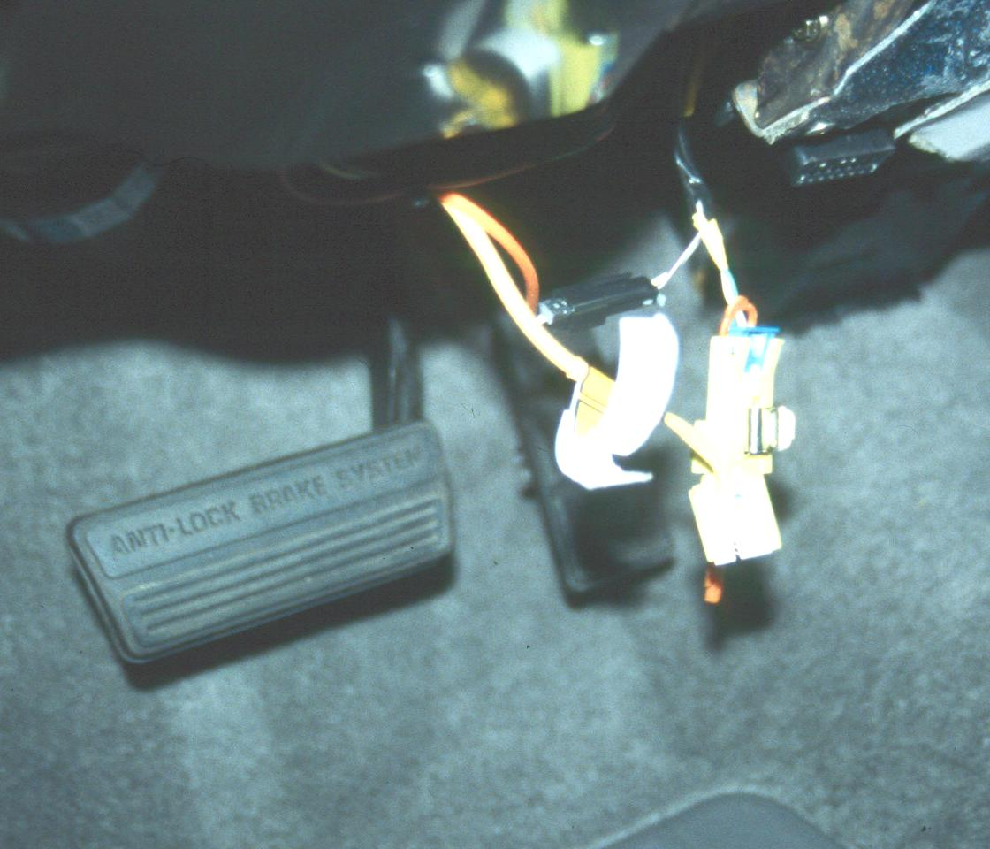
on or around the steering column or dash areas of a vehicle
equipped with airbags.

1. Check service information for the specified method
to use to disarm and enable the airbags.
______________________________________
______________________________________
______________________________________

2. Disconnect the negative (-) battery cable.

3. Locate and remove the airbag fuse.

Label of fuse = ________________________
Amperage rating of the fuse = ____________
4. Remove the covering from underneath the steering column to gain access to the
steering column airbag wiring connector.

5. Disconnect the yellow airbag electrical connector.

6. Locate and disconnect the yellow passenger side airbag electrical connector.

Describe the location __________________________________________

What components had to be removed to gain access to the passenger side airbag connector? ___________________________________________

7. After servicing the steering column or dash, restore the airbags by reconnecting the
connectors, installing the airbag circuit fuse, and reconnecting the battery.

8. Start the engine and check for proper operation of the airbag warning light.

OK NOT OK

