**Meets ASE Task:** (A6-G-7) P-1 Diagnose operation of safety systems and related circuits (such as: horn, airbags, seat belt pretensioners, occupancy classification, wipers, washers, speed control/collision avoidance, heads-up display, parking assist, and back-up camera); determine needed action.

Name:_____________________________________

Date:_____________

Time on Task:_____________

Make/Model/Year:____________________________________

VIN:_________________________________

Evaluation (Enter number from 4, 3, 2, 1) :_________

**Airbag Diagnosis**

Page 182

**1.** Check service information for specified diagnostic test procedures. ______________

_________________________________________________________________

**2.** Locate the airbag schematic and determine the following information.

a. Describe the location of the airbag controller__________________________

_________________________________________________________________

b. Describe the location of the arming sensor ____________________________

__________________________________________________________________

c. Describe the location of the discriminating sensors _____________________

__________________________________________________________________

**3.** What fuse number (label) and amperage rating is used for the airbag?

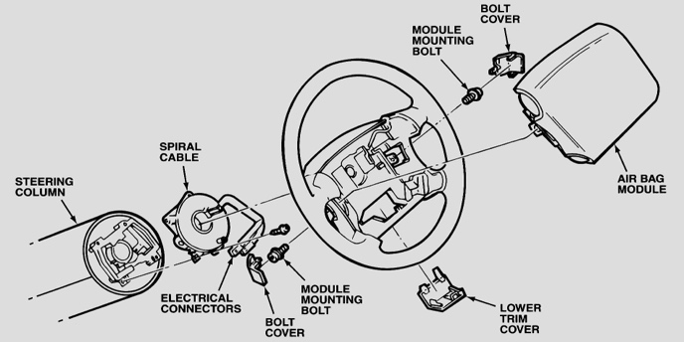 a. Fuse number (label) __________

b. Fuse rating _________________

**4.** Describe the location of the ground(s) for

the airbag. ____________________

__________________________

**5.** Based on the diagnostic tests, what is the needed action? _______________________

__________________________________________________________________

__________________________________________________________________