A feeler gauge (also known as a thickness gauge) is an accurately manufactured strip of metal that is used to determine the gap or clearance between two components. Use a feeler gauge to check the following.

Evaluation (Enter number from 4, 3, 2, 1) :_________

Meets ASE task: **(**A0-B-5) Demonstrate proper use of precision measuring tools (e.g., micrometer, dial-indicator, dial-caliper).

**Feeler Gauge**

Name:_____________________________________

Date:_____________

Time on Task:_____________

Make/Model/Year:____________________________________

VIN:_________________________________

Page 18

**1.** Piston ring end gap = ______________________________

Specification = ___________ (normally 0.004 in. per inch of bore)

**OK  NOT OK**

**2.** Piston ring side clearance = ______________________________

Specification = ___________ (normally 0.001 to 0.003 in.)

**OK  NOT OK**

**3.** Piston-to-cylinder wall clearance = ____________________________

Specification = ___________ (normally 0.001 to 0.003 in.)

**OK  NOT OK**

**4.** Connecting rod side clearance = ______________________________

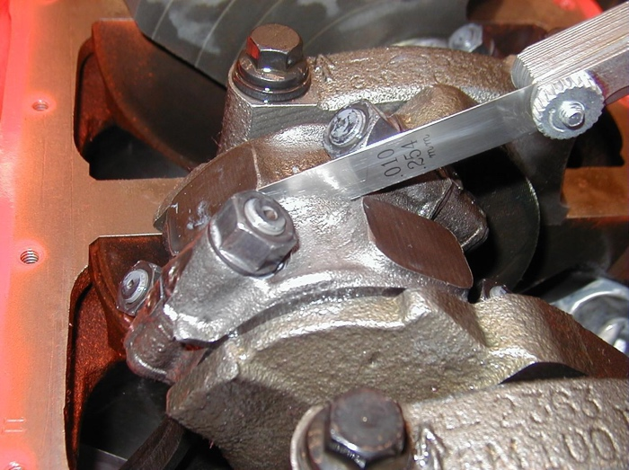

Specification = ___________

**OK  NOT OK**