Meets ASE Task: (A6-G-8) P-1 Diagnose body electronic systems circuits using a scan tool; check for module communication errors (data bus systems); determine needed action.
Name:_____________________________________
Date:_____________
Time on Task:_____________
Make/Model/Year:____________________________________
VIN:_________________________________
Evaluation (Enter number from 4, 3, 2, 1) :_________
Body and Module Communication Diagnosis
Page 179
1. Check service information for the procedures to follow for diagnosing body electronic
system diagnosis using a scan tool.
__________________________________________________________________

__________________________________________________________________
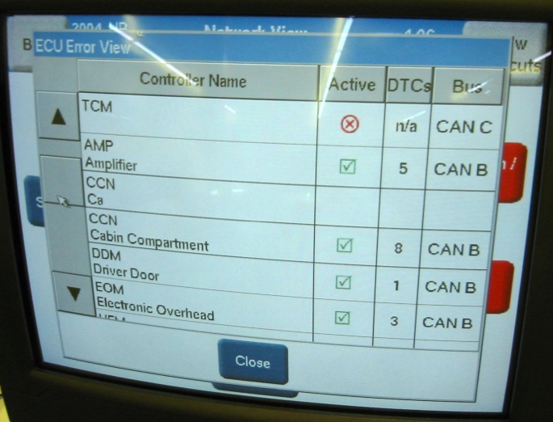
2. Check all that apply:
Use a factory scan tool.

Use a global OBD-II scan tool.

Use a DMM to check for resistance
on communication circuits.

Use a fused jumper wire and a scan
tool to diagnose communication
errors.

Other (describe) ________________________________________________

3. List the systems or components that can be accessed using a scan tool.
a. ___________________________ f. __________________________
b. ___________________________ g. __________________________
c. ___________________________ h. __________________________
d. ___________________________ j. ___________________________
e. ___________________________ k. ___________________________
other (specify) _____________________________________________________
4. List components or modules that can communicate with the scan tool. _____________

__________________________________________________________________

