Meets ASE Task: (A6-G-2) P-1 Remove and reinstall door panel.
Name:_____________________________________
Date:_____________
Time on Task:_____________
Make/Model/Year:____________________________________
VIN:_________________________________
Evaluation (Enter number from 4, 3, 2, 1) :_________
Door Panel
Page 178
1. Check service information for the specified procedures to follow to remove and

reinstall a door panel. ___________________________________________________

__________________________________________________________________

2. List the tools needed. ___________________________________________________

3. Show the instructor the removed door panel. Instructor’s OK ___________
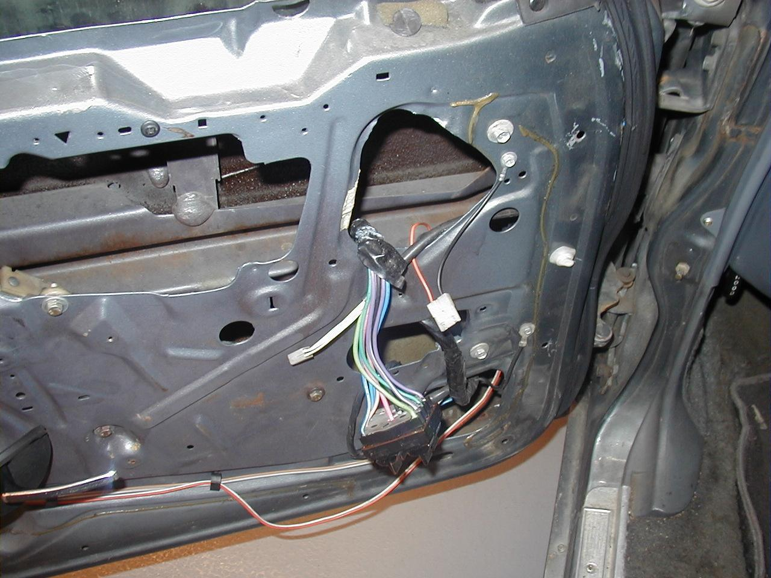

4. How many clips and fasteners hold the door panel? ________________________

5. Show the instructor the reinstalled door panel. Instructor’s OK ___________

