Meets ASE Task: (A6-G-1) P-2 Demonstrate understanding and diagnose vehicle comfort, convenience, access, safety, and related systems operation; determine needed action.
Name:_____________________________________
Date:_____________
Time on Task:_____________
Make/Model/Year:____________________________________
VIN:_________________________________
Evaluation (Enter number from 4, 3, 2, 1) :_________
Power Accessory Diagnosis
Page 177
1. Check service information for specified testing procedures to diagnose fault(s) in the
power accessory systems.
_________________________________________________________________
_________________________________________________________________
2. Locate the power window schematics and determine the following information.
a. Describe the location of the power window master control switch __________
___________________________________________________________
b. Describe the location of the rear defogger relay ________________________
___________________________________________________________
c. Describe the location of the cruise control servo unit (if equipped) _________
____________________________________________________________
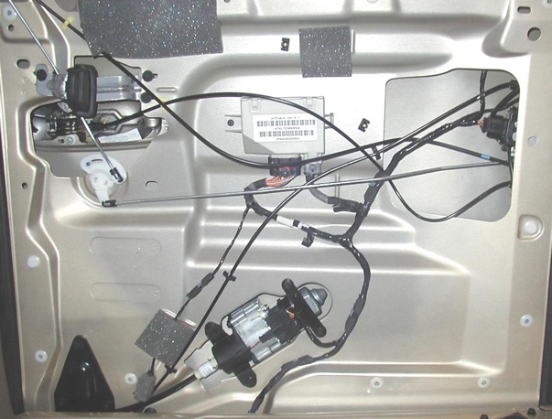
3. Describe the specified testing procedure (major steps)
______________________________________
______________________________________
______________________________________
______________________________________
4. Describe the ground(s) for the power windows.
_________________________________________
_________________________________________

5. Based on the inspection and test results, what is the needed action? _______________
__________________________________________________________________

