Meets ASE Task: (A6-G-7) P-1 Diagnose operation of safety systems and related circuits (such as: horn, airbags, seat belt pretensioners, occupancy classification, wipers, washers, speed control/collision avoidance, heads-up display, parking assist, and back-up camera); determine needed action.

Name:_____________________________________
Date:_____________
Time on Task:_____________
Make/Model/Year:____________________________________
VIN:_________________________________
Evaluation (Enter number from 4, 3, 2, 1) :_________
Windshield Wiper/Washer
Page 176
1. Check service information for the specified testing procedure for a fault with the
windshield wiper or washer_______________________________________________
__________________________________________________________________
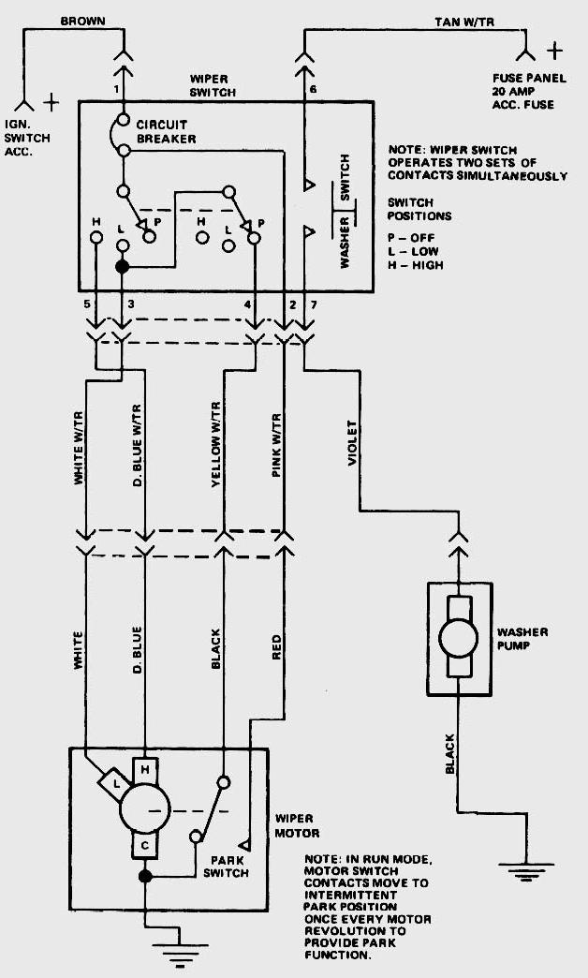
2. Operate the windshield wipers on all speeds.
OK NOT OK

3. Locate the windshield wiper/washer and describe
their locations: _____________________________
__________________________________________

4. List the wire colors that are attached to the
windshield wiper/washer motor assembly.
Wiper Washer
a. _______________ a. ________________
b. _______________ b. ________________
c. _______________ c. ________________

5. Based on the specified test results, what is the needed action? ___________________
_________________________________________________________________

