**Meets ASE Task:** (A6-G-7) P-1 Diagnose operation of safety systems and related circuits (such as: horn, airbags, seat belt pretensioners, occupancy classification, wipers, washers, speed control/collision avoidance, heads-up display, parking assist, and back-up camera); determine needed action.

Name:_____________________________________

Date:_____________

Time on Task:_____________

Make/Model/Year:____________________________________

VIN:_________________________________

Evaluation (Enter number from 4, 3, 2, 1) :_________

**Horn**

Page 175

**1.** Locate the horn(s) and describe their location. _______________________________

_________________________________________________________________

**2.** One horn or two? __________________

**3.** What is the color of the wire to the horn(s)? ________________________________

**4.** Locate the horn relay and describe its location. ______________________________

**5.** The colors of the wires on the relay include: ________________, _______________,

________________, ________________, ________________

**6.** Check the service information and compare the wire colors with the wiring schematic.

Agree? **Yes**  **No** If no, what is the difference? ___________________

**6.** List the diagnostic procedure steps if the horn is inoperable.

1. ______________________ 6. ______________________

2. ______________________ 7. ______________________

3. ______________________ 8. ______________________

4. ______________________ 9. ______________________

5. ______________________ 10.______________________

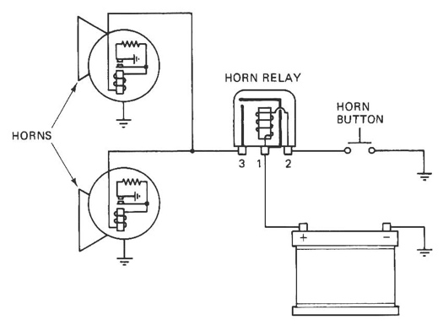

**7.** What is the needed action? ________________________________

_________________________________________________