**Meets ASE Task:** (A6-F-3) P-1 Diagnose (troubleshoot) the causes of incorrect operation of warning devices and other driver information systems; determine needed action.

Name:_____________________________________

Date:_____________

Time on Task:_____________

Make/Model/Year:____________________________________

VIN:_________________________________

Evaluation (Enter number from 4, 3, 2, 1) :_________

**Driver Information and Warning Devices**

Page 173

**1.** Check service information for the specified testing procedures to test the gauge

printed circuit boards, and diagnosis of warning devices.________________________

__________________________________________________________________

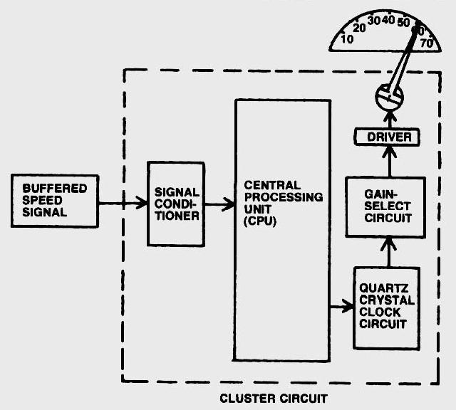

**2.** Perform a visual inspection of the wires and connectors to the printed circuit boards.

**OK**

**NOT OK** (describe fault) _______________________________________

**3.** Visually check the gauge printed circuit boards for discoloration or poor solder joints.

**OK**

**NOT OK** (describe fault)

**4.** Based on the tests and inspection, what is the needed action? _________________

_________________________________________________________________