Meets ASE Task: (A6-F-2) P-1 Inspect and test gauges and gauge sending units for causes of abnormal readings; determine needed action.
Name:_____________________________________
Date:_____________
Time on Task:_____________
Make/Model/Year:____________________________________
VIN:_________________________________
Evaluation (Enter number from 4, 3, 2, 1) :_________
Gauge Diagnosis
Page 172
1. Locate the wiring schematic for the dash gauge circuits and determine the color of the
wires.
Fuel gauge ____________, ____________, and ____________
Oil pressure coolant temperature __________, ____________, and __________
Color of wires to the sending unit: _______________ and _________________
2. Check service information and determine the specified resistance of the sending unit
when the gas tank is full and empty.
Full tank = _______________ Empty tank = _______________
3. Determine the resistance specification of the sending unit.
Resistance of the sending unit when the oil pressure is high = _______________
Resistance of the sending unit when the oil pressure is low = ________________
4. Determine the specified resistance of the sensor when hot and cold.
Resistance when the coolant is cold = ______________________________
Resistance when the coolant is hot = _______________________________
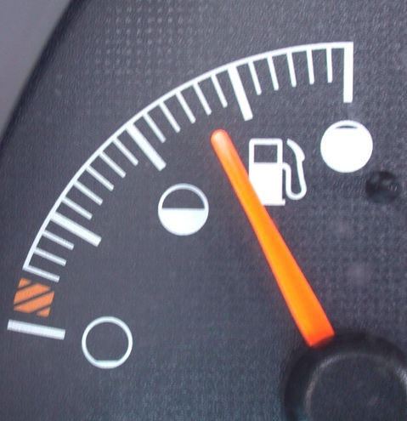
5. Based on the tests, what is the needed action?
______________________________
______________________________
______________________________
______________________________

