Meets ASE Task: (Not specified by ASE)
Name:_____________________________________
Date:_____________
Time on Task:_____________
Make/Model/Year:____________________________________
VIN:_________________________________
Evaluation (Enter number from 4, 3, 2, 1) :_________
High-Intensity Discharge Headlights
Page 170
1. Check service information for the specified precautions when working with high-
intensity discharge (HID) lights. The safety precautions include:

a. ___________________________________________________________

b. ___________________________________________________________

c. ___________________________________________________________

2. What is the voltage output of the HID ballast assembly? ________________

3. What is the specified testing procedure for diagnosing faults with high-intensity
discharge lighting systems?

Step 1: ___________________________________________________________

Step 2: ___________________________________________________________

Step 3: ___________________________________________________________

Step 4: ___________________________________________________________

4. List the tools and test equipment needed to test high-intensity discharge headlight
systems.
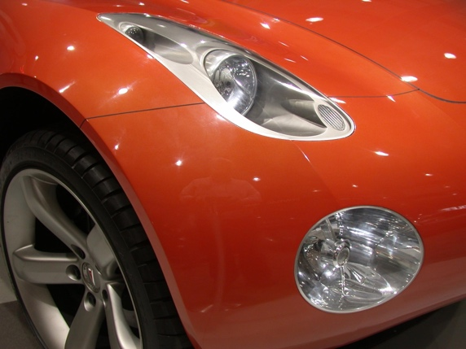
a. ___________________________________
b. ___________________________________
c. ___________________________________

d. ___________________________________

