A dial caliper is usually used to measure the outside diameter or length of a component such as a piston diameter or crankshaft and camshaft bearing journal diameter. Use a vernier dial caliper to measure the following items.
Evaluation (Enter number from 4, 3, 2, 1) :_________

Meets ASE task: (A0-B-5) Demonstrate proper use of precision measuring tools (e.g., micrometer, dial-indicator, dial-caliper).
Dial Caliper

Name:_____________________________________
Date:_____________
Time on Task:_____________
Make/Model/Year:____________________________________
VIN:_________________________________
Page 17

1. Pushrod diameter = _______
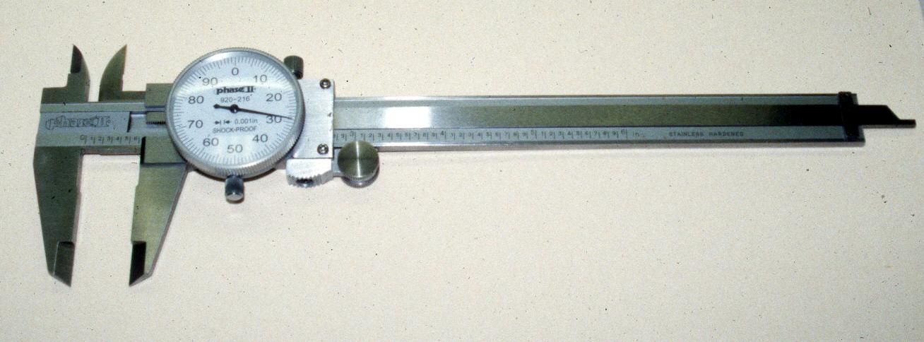

2. Intake valve stem diameter = _______

3. Exhaust valve stem diameter = ______

4. Camshaft bearing diameter = _______

5. Piston diameter = ______

Check the factory specifications for exact location on the piston to measure the
diameter.

Location = ___________________________

6. Crankshaft main bearing journal diameter = ________________

7. Crankshaft rod bearing journal diameter = _________________

