Meets ASE Task: (A6-E-3) P-1 Diagnose (troubleshoot) the causes of brighter-than-normal, intermittent, dim, or no light operation; determine needed action.
Name:_____________________________________
Date:_____________
Time on Task:_____________
Make/Model/Year:____________________________________
VIN:_________________________________
Evaluation (Enter number from 4, 3, 2, 1) :_________
Lighting System Diagnosis
Page 169
1. Check service information for the specified lighting diagnosis procedures and
specifications.

_________________________________________________________________

_________________________________________________________________

2. What type of headlights are used on the vehicle?

Sealed beam
Halogen replacement bulbs
High-intensity discharge (HID)
Other (describe) _______________________________________________

3. Is alignment equipment needed? Yes No

If yes, describe: ____________________________________________________

4. Is the headlight unit equipped with a bubble level? Yes No

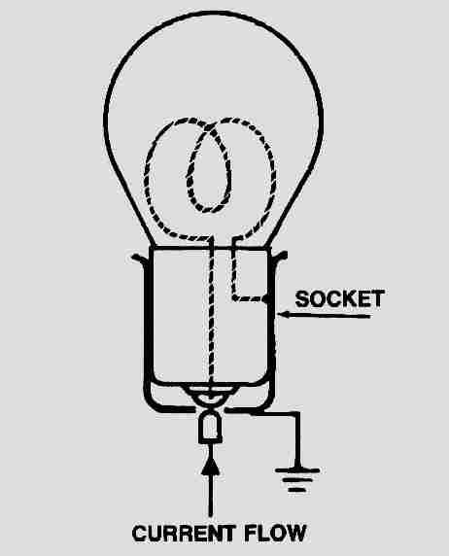
5. Is the correct bulb trade number installed? Yes No

6. Check for proper power and ground at the socket of the bulb.

OK NOT OK (describe fault) ________________

____________________________________________________

7. Based on the inspection and testing, what is the needed action?

___________________________________________________

___________________________________________________

