Meets ASE Task: (A6-D-4) P-2 Perform charging circuit voltage drop tests; determine needed action.
Name:_____________________________________
Date:_____________
Time on Task:_____________
Make/Model/Year:____________________________________
VIN:_________________________________
Evaluation (Enter number from 4, 3, 2, 1) :_________
Charging Circuit Voltage Drop
Page 168
1. Check service information for specified procedures and voltage drop specifications of
the charging circuit.

2. Connect one test lead of a digital multimeter set to read DC volts to the alternator
output terminal and the positive (+) terminal of the battery.

3. Start the engine and run to 2,000 RPM (fast idle).

4. Turn on the headlights to force the alternator to charge the battery.

5. The voltage drop reading should not exceed 0.40 volt.

_____ = the voltage drop of the insulated (power side) of the charging circuit
(between the output terminal of the alternator and the positive (+)
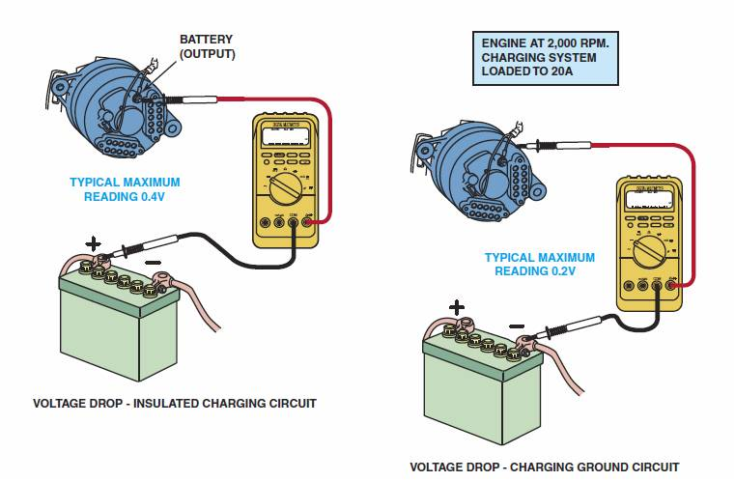
terminal of the battery).

OK NOT OK

6. To test if the generator is properly grounded,
continue operating the engine at a fast
idle with the lights on, connect the meter
leads to the case of the alternator and the
negative (-) terminal of the battery. A
reading of greater than 0.20 volt indicates a
poor alternator ground.

_____ = the voltage drop of the ground side of the alternator (between the rear
housing of the alternator and the negative (-) terminal of the battery).

OK NOT OK

7. Based on the test results, what is the needed action? ___________________________

__________________________________________________________________

