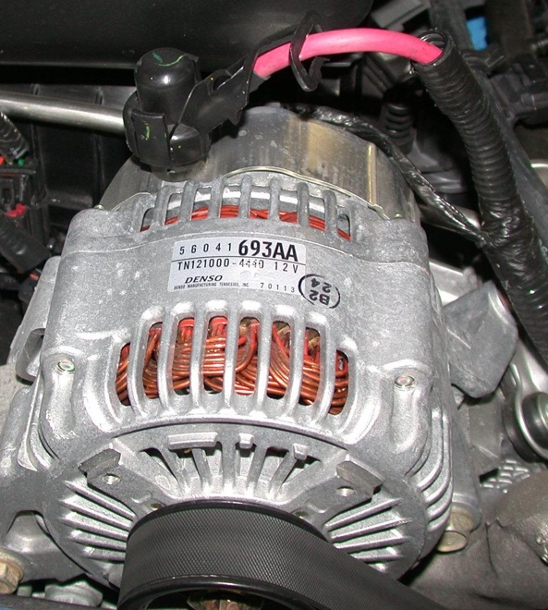
Meets ASE Task: (A6-D-3) P-1 Remove, inspect, and/or replace generator (alternator); determine needed action.
Name:_____________________________________
Date:_____________
Time on Task:_____________
Make/Model/Year:____________________________________
VIN:_________________________________
Evaluation (Enter number from 4, 3, 2, 1) :_________
Remove and Install Alternator
Page 167
1. Check service information for the specified
procedures for the removal and installation
of a generator alternator in a vehicle.

_________________________________

_________________________________

_________________________________

_________________________________

_________________________________

2. Does the service information require that the battery be disconnected? Yes No

3. What are the torque specifications for the alternator fasteners? _________

_________________________________________________________________

4. What is the condition of the drive belt, pulley, and tensions? ___________________

_________________________________________________________________

5. Show the instructor the alternator removed from the vehicle. Instructor’s OK _____

6. Show the instructor the alternator installed in the vehicle. Instructor’s OK _____

