**Meets ASE Task:** (A6-D-5) P-1 Diagnose charging system for causes of undercharge, no-charge, or overcharge conditions; determine needed action.

Name:_____________________________________

Date:_____________

Time on Task:_____________

Make/Model/Year:____________________________________

VIN:_________________________________

Evaluation (Enter number from 4, 3, 2, 1) :_________

**Charging System Diagnosis**

Page 165

**1.** Check service information for:

a. Specified charging system voltage specifications and testing procedures

______________________________________________________________

b. Specified charging system voltage = ____________________

c. Specified charging system diagnostic procedure = ______________________

______________________________________________________________

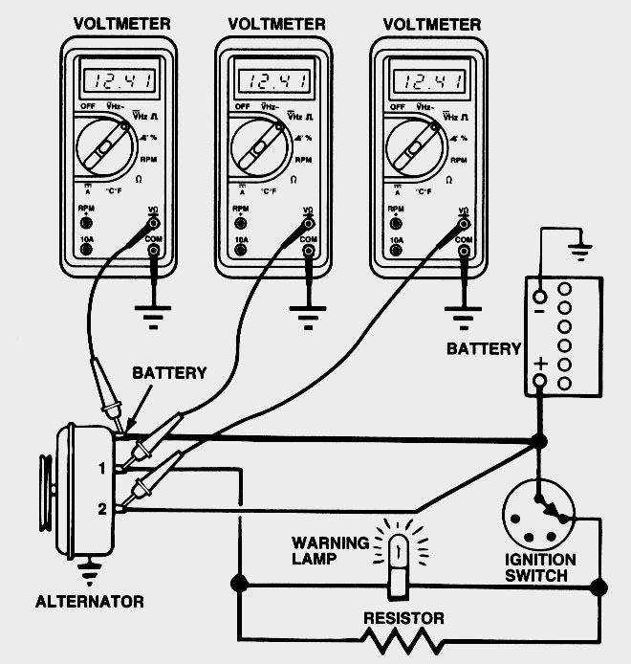

**2.** Measure the charging system voltage = ________________.

**3.** Measure the AC ripple voltage - ________ (should be less than 0.5 volt).

**4.** Based on the test results, what is the needed action? _________________________

__________________________________________________________________