Meets ASE Task: (A6-D-1) P-1 Perform charging system output test; determine needed action.

Name:_____________________________________
Date:_____________
Time on Task:_____________
Make/Model/Year:____________________________________
VIN:_________________________________
Evaluation (Enter number from 4, 3, 2, 1) :_________
Charging System Output Test
Page 164
1. Check service information for the specified charging system output test procedures
and specifications.
__________________________________________________________________

2. Connect the starting and charging test unit leads to the battery as per the
manufacturer's instructions.

3. Attach the amp probe around the alternator output wire.

4. Start the engine and operate at 2,000 RPM (fast idle).

5. Turn the "load increase" control slowly to obtain the highest reading on the ammeter
scale. (Do not let the battery voltage drop to less than 12 volts.)
Tested amps = __________ amps.

6. Specification (should be stamped on the alternator or indicated by a
colored tag on or near the output terminal) = _________ amps.

7. Results should be within 10% of the specifications. If the alternator amperage output
is low, first check the condition of the alternator drive belt. The alternator should not
be able to be rotated by hand with the engine "off."
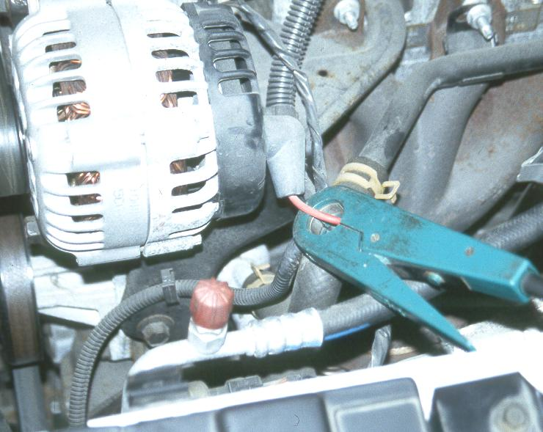
OK NOT OK

8. Based on the results of the charging system
output test, what is the needed action?
__________________________________________________________________

__________________________________________________________________

