Meets ASE Task: (Not specified by ASE)
Name:_____________________________________
Date:_____________
Time on Task:_____________
Make/Model/Year:____________________________________
VIN:_________________________________
Evaluation (Enter number from 4, 3, 2, 1) :_________
Alternator Rectifier Bridge Testing
Page 163
1. Identify the type of alternator.
GM
Ford
Chrysler
other (specify) _______________________________

2. How many diodes are used in the rectifier bridge (2 per stator winding)?
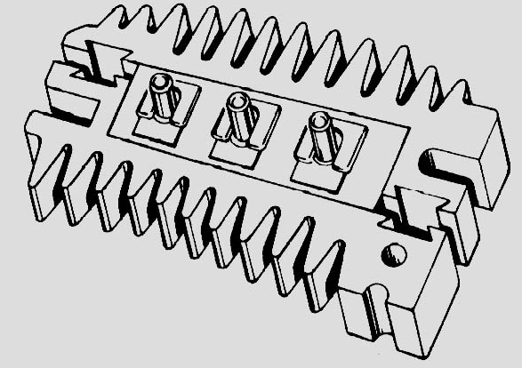
6
8
other (specify) ________________

3. Visually check the rectifier bridge for physical
damage.

OK NOT OK

4. Set a digital multimeter to the diode check
position.

5. Touch one meter lead to the terminal of the diode and the other lead to the heat sink
for the same diode and record the reading. Reverse the leads and record the second
reading. A good diode should read infinity (OL) one way and record a voltage drop
reading of between 0.4 volt (400 mV) and 0.6 volt (600 mV) the other way.
reading for diode #1 = __________ and ___________
reading for diode #2 = __________ and ___________
reading for diode #3 = __________ and ___________
reading for diode #4 = __________ and ___________
reading for diode #5 = __________ and ___________
reading for diode #6 = __________ and ___________

OK NOT OK

6. Test the diode trio (if equipped) in a similar manner. OK NOT OK

