Meets ASE Task: (Not specified by ASE)
Name:_____________________________________
Date:_____________
Time on Task:_____________
Make/Model/Year:____________________________________
VIN:_________________________________
Evaluation (Enter number from 4, 3, 2, 1) :_________
Alternator Stator Testing
Page 162
1. Identify the type of stator.

Wye (has three terminals with one wire at
each terminal and a wire junction)

Delta (has three terminals with two wires
at each terminal)

2. Visually inspect the rotor for faults such as burned insulation due to overheating or
broken wires.

OK NOT OK
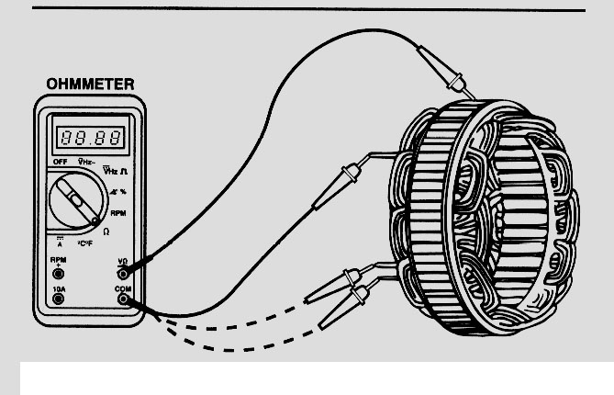

3. Set a digital multimeter to read ohms (low
scale).

4. Measure the resistance between all three
terminals of the stator two at a time. The
resistance will be low (usually less than 2 ohms).
If high or infinity, the stator is defective.

OK NOT OK

5. To check if the stator windings are shorted-to-ground, connect one lead of the meter
(still set to read ohms) to the steel laminations of the stator and touch the other lead to
each of the three terminals. The reading on all three terminals should be infinity (OL).

OK NOT OK

