**Meets ASE Task:** (Not specified by ASE)

Name:_____________________________________

Date:_____________

Time on Task:_____________

Make/Model/Year:____________________________________

VIN:_________________________________

Evaluation (Enter number from 4, 3, 2, 1) :_________

**Alternator Disassembly**

Page 160

**1.** Visually check the alternator for physical damage.

**OK _____ NOT OK _____**

**2.** Use a marker or scribe to mark the case of the alternator so it can be correctly

reassembled in the same “clock position.”

**3.** Remove the through bolts and separate the alternator.

**NOTE:** The laminations of the stator should be held against the rear half of the alternator.

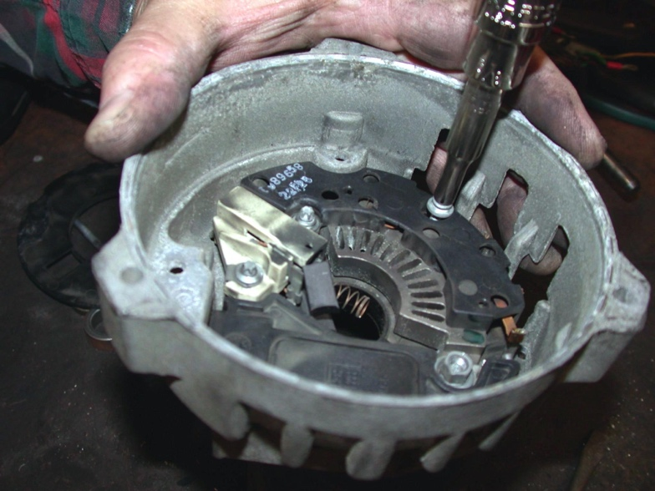

**4.** Remove the stator from the rectifier bridge.

**5.** Remove the brushes and voltage regulator.

**6.** Remove the rectifier bridge.

**7.** Thoroughly clean and test the alternator parts before reassembly.