A micrometer is the most used measuring instrument in engine service and repair. The thimble rotates over the barrel on a screw that has 40 threads per inch. Every revolution of the thimble moves the spindle 0.025 inch. The thimble is graduated into 25 equally spaced lines; therefore, each line represents 0.001 inch. Measure and record the following engine components.
Evaluation (Enter number from 4, 3, 2, 1) :_________

Meets ASE task: (A0-B-5) Demonstrate proper use of precision measuring tools (e.g., micrometer, dial-indicator, dial-caliper).
Micrometer
Name:_____________________________________
Date:_____________
Time on Task:_____________
Make/Model/Year:____________________________________
VIN:_________________________________
Page 16

1. Pushrod diameter = _____________

2. Intake valve stem diameter = ___________

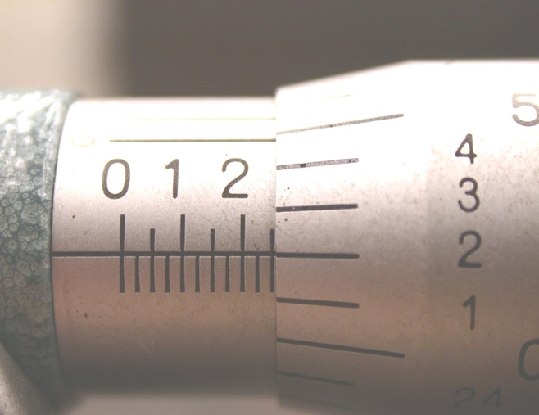
3. Exhaust valve stem diameter = __________

4. Camshaft bearing diameter = ________

5. Piston diameter = _________________

Check the factory specifications for
exact location on the piston to measure
the diameter.

Location = ______________________

6. Crankshaft main bearing journal diameter = ________________

7. Crankshaft rod bearing journal diameter = _________________

