Meets ASE Task: (A6-A-2) P-1 Identify electrical/electronic system components and configurations.
Name:_____________________________________
Date:_____________
Time on Task:_____________
Make/Model/Year:____________________________________
VIN:_________________________________
Evaluation (Enter number from 4, 3, 2, 1) :_________
Alternator Identification
Page 159
1. Locate the alternator and describe the location. ______________________

__________________________________________________________________

2. Check service information and determine the maximum amperage output and charging
system voltage.

- Amperage rating (usually ranges from 60 A to 160 A) ___________

- Charging system voltage (usually within 13.5 to 15.0 volts) ___________

3. Locate the alternator and identify which wire(s) supply electrical power to
the vehicle electrical system and battery.

- Color of power lead wire(s) __________________________________

- Wire gauge of the power lead wire(s) __________________

4. What type of electrical protection is included in the alternator output circuit?

Fusible link (describe location) __________________________________

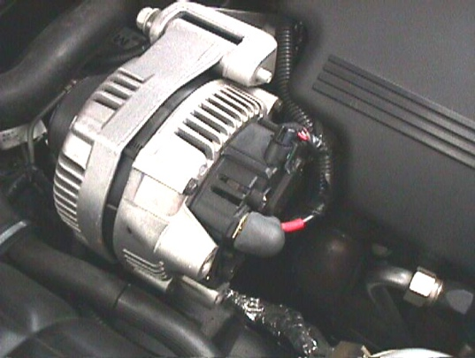
Maxi fuse (rating = _______________)

Describe location _______________________

Unknown

