Meets ASE Task: : (A6-C-3) P-2 Inspect and test starter relays and solenoids; determine needed action.

Name:_____________________________________
Date:_____________
Time on Task:_____________
Make/Model/Year:____________________________________
VIN:_________________________________
Evaluation (Enter number from 4, 3, 2, 1) :_________
Starter Relays and Solenoids
Page 157
1. Clean and visually inspect the starter solenoid and/or relay for physical damage.
OK NOT OK
2. Set a digital multimeter (DMM) to read ohms (low scale) and check the hold-in coil
and the pull-in coil.

Pull-in coil. Measure between terminals “S” and “M”:
resistance = ______ (should be 0.2 to 0.4 ohm) OK NOT OK

Hold-in coil. Measure between terminals “S” and the solenoid housing:
resistance = _______ (should be 0.4 to 0.6 ohm) OK NOT OK

3. Test the pull-in winding by applying 12 volts to terminal “S” and ground to terminal
“M.” Check that the plunger will be drawn into the solenoid.
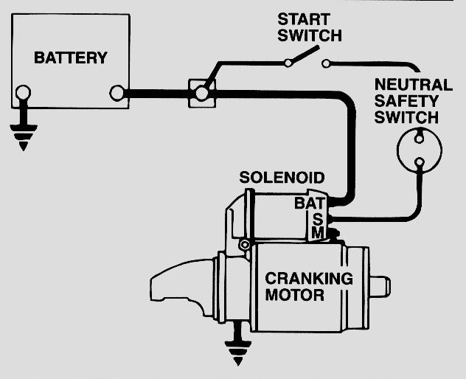
OK NOT OK

4. Check the hold-in winding by connecting 12 volts
to terminal “S” and the other wire to ground. The
plunger should be drawn into the solenoid housing.

OK NOT OK

5. Measure coil resistance of the relay (terminals 86 and
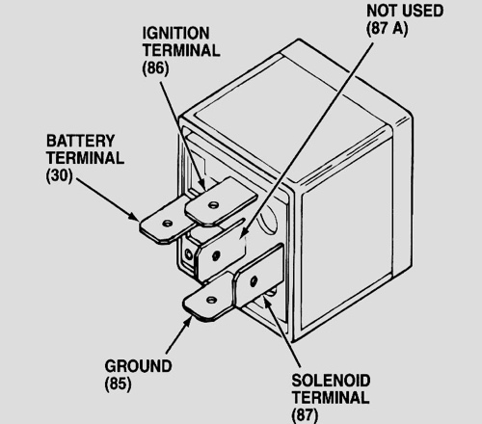
85).

Resistance = ______ ohms
(should be 60 to 100 ohms)

OK NOT OK

6. What is the needed action?
_____________________________________
_____________________________________

