Meets ASE Task: : (A6-C-1) P-1 Perform starter current draw tests; determine needed action. (A6-C-2) P-1 Perform starter circuit voltage drop tests; determine needed action.

Name:_____________________________________
Date:_____________
Time on Task:_____________
Make/Model/Year:____________________________________
VIN:_________________________________
Evaluation (Enter number from 4, 3, 2, 1) :_________
Starter Voltage Drop/Current Draw Tests
Page 156
1. Check service information for the specified starter current draw test procedure and
specifications.

__________________________________________________________________
__________________________________________________________________

NOTE: Few vehicle manufacturers give starter current draw specifications with the starter installed on the vehicle. Use the chart below as a guideline regarding the range of the maximum allowable starter draw.
4-cylinder engines = 150 to 185 amperes maximum (normally less than 100 A)
6-cylinder engines = 160 to 200 amperes maximum (normally less than 125 A)
8-cylinder engines = 185 to 250 amperes maximum (normally less than 150 A)
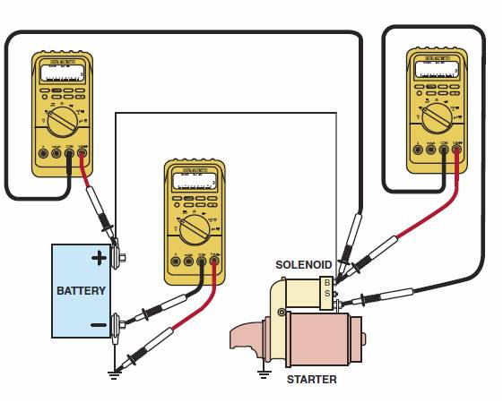
2. Perform the starter current draw test following the
manufacturer’s instructions.

Results: ________ amperes

3. Connect the voltmeter, as shown in the
illustration, and crank the engine. Observe the
voltmeter.

4. All test results should be less than 0.2 V (200 mV).

5. Based on the specifications and the test results, what is the needed action?

________________________________________________________________

________________________________________________________________

________________________________________________________________

