Meets ASE Task: (A6-C-6) P-1 Demonstrate knowledge of an automatic idle-stop/start-stop system.
Name:_____________________________________
Date:_____________
Time on Task:_____________
Make/Model/Year:____________________________________
VIN:_________________________________
Evaluation (Enter number from 4, 3, 2, 1) :_________
Idle Stop/Start-Stop Systems
Page 155
1. What is the purpose and function of a stop-start system (consult service information?
Describe the purpose and function. ______________________________________
___________________________________________________________________
___________________________________________________________________

2. What terms are used to describe this system?
________________________
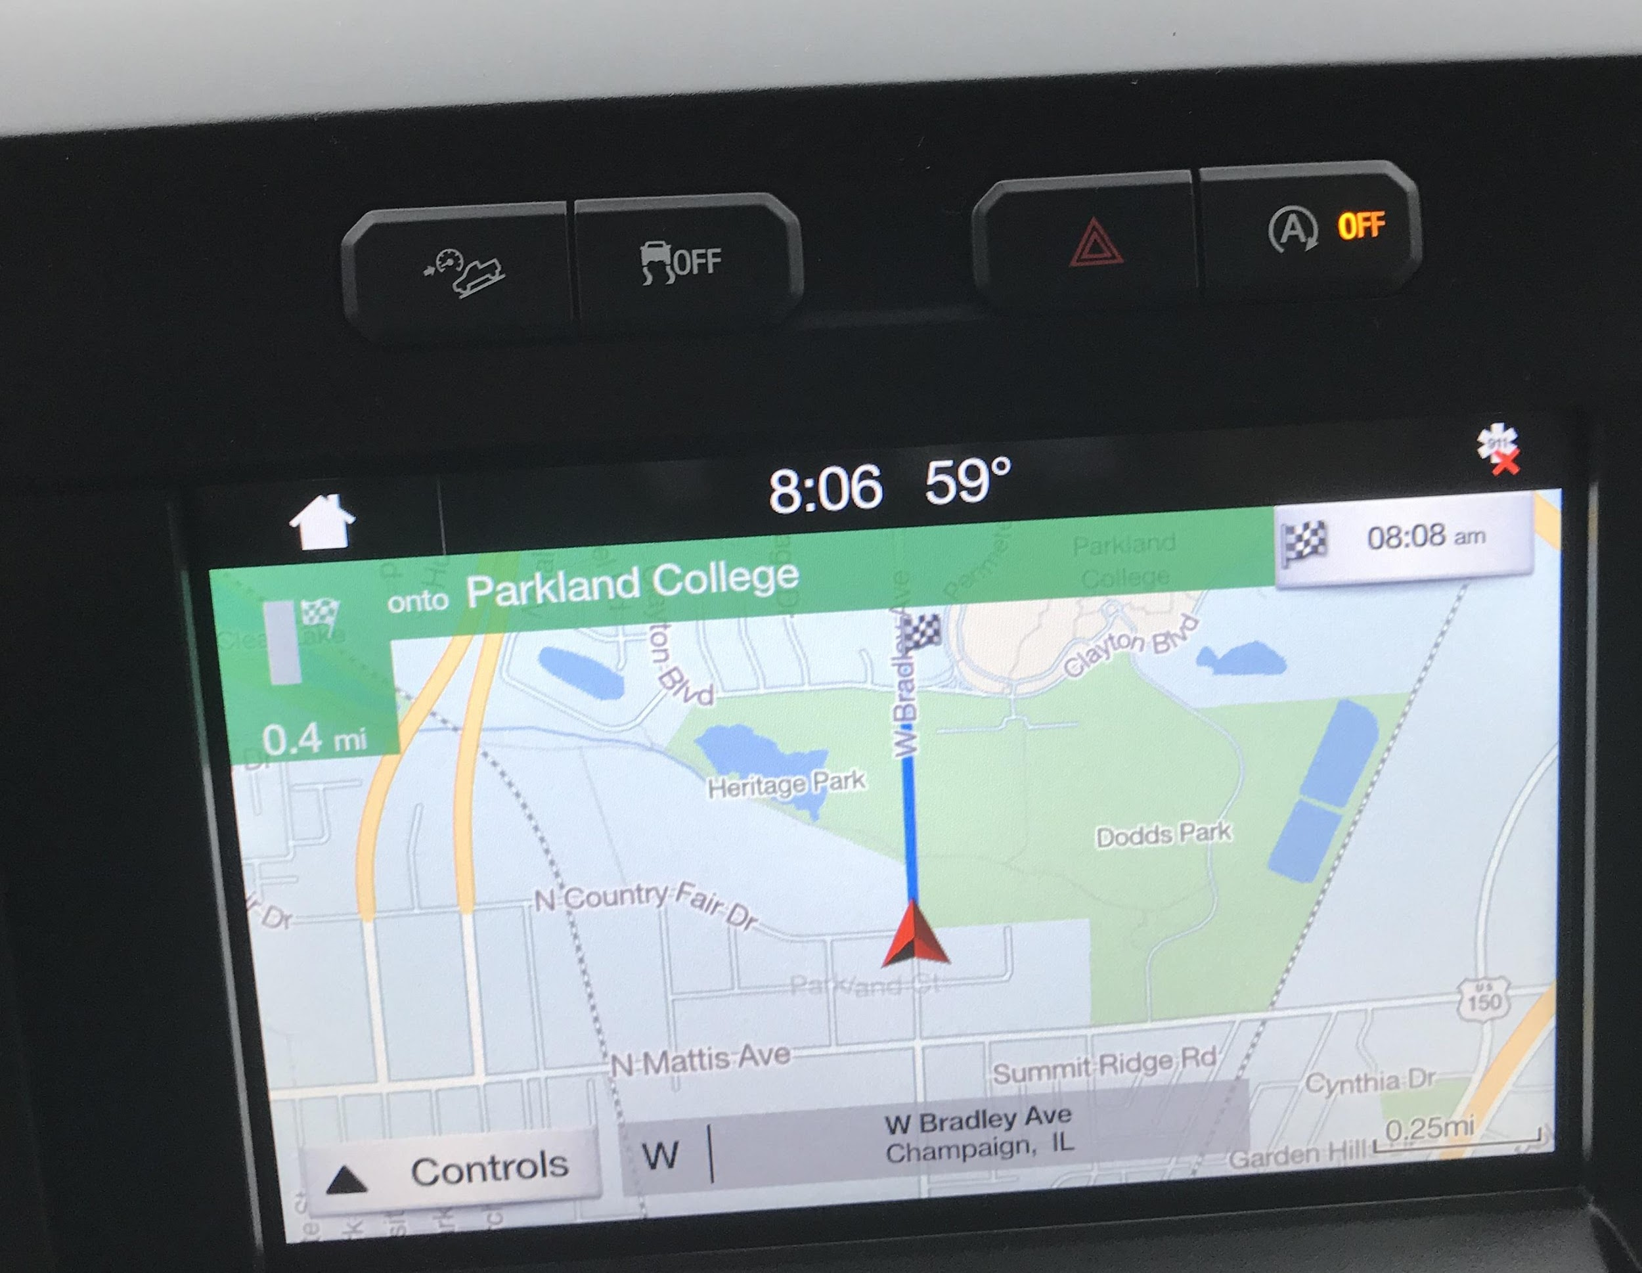
________________________
________________________
________________________

3. Can the stop-start system be turned off?
Yes
No
Unsure

