Meets ASE Task: (A6-A-2) P-1 Identify electrical/electronic system components and configurations.
Name:_____________________________________
Date:_____________
Time on Task:_____________
Make/Model/Year:____________________________________
VIN:_________________________________
Evaluation (Enter number from 4, 3, 2, 1) :_________
Cranking System Identification
Page 153
1. Locate the battery and describe its location: _________________________________
_________________________________________________________________
2. Check service information and determine the location of the ignition switch (not the
ignition lock assembly) and describe its location. _____________________________
_________________________________________________________________
3. Check service information and determine the location of the starter solenoid.
Attached to the starter motor
Remotely mounted (describe the location) __________________
____________________________________________________
4. What is the color of the wire from the ignition start (crank) position on the ignition
switch to the starter solenoid “S” terminal? ___________________________
5. Describe the location of the starter motor. ___________________________________
_________________________________________________________________
6. After checking the service information, list the steps needed to remove the starter
motor.
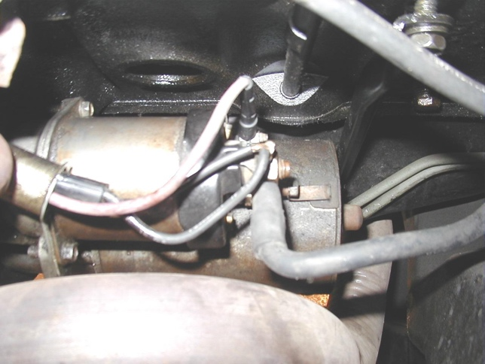
1. ___________________________ 2. ___________________________
3. ___________________________
4. ___________________________ 5. ___________________________
6. ___________________________
7. ___________________________
8. ___________________________

