Meets ASE Task: (Not specified by ASE)

Name:_____________________________________
Date:_____________
Time on Task:_____________
Make/Model/Year:____________________________________
VIN:_________________________________
Evaluation (Enter number from 4, 3, 2, 1) :_________
Hybrid Auxiliary Battery
Page 152
1. Check service information for the location of the hybrid vehicle auxiliary (12V)

battery. ____________________________________________________

__________________________________________________________________

__________________________________________________________________
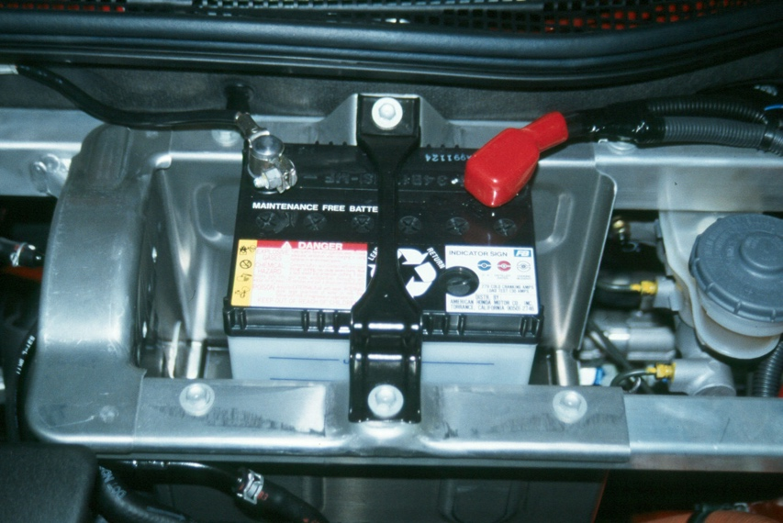

2. What are the battery specifications? CCA = ______ Size = _________

3. Describe the service procedures: __________________________________________

_________________________________________________________________

_________________________________________________________________

4. Based on the specified test results, what is the needed action? ___________________

__________________________________________________________________

__________________________________________________________________

