Meets ASE Task: (A6-B-6) P-1 Jump-start vehicle using jumper cables and a booster battery or an auxiliary power supply.

Name:_____________________________________
Date:_____________
Time on Task:_____________
Make/Model/Year:____________________________________
VIN:_________________________________
Evaluation (Enter number from 4, 3, 2, 1) :_________
Jump Starting
Page 150
1. Move the good vehicle to within reach of the jumper cables of the disabled vehicle (or
use a portable jumper box).

2. Check that the ignition is in the “off” position on both vehicles.

3. Connect the jumper cables in the following order:

a. Red cable ends to the positive (+) terminals of both batteries
b. One black cable end to the negative (-) terminal of the good vehicle
c. The other black cable end to a good, unpainted engine ground at least one
foot from the battery

4. Start the good vehicle.
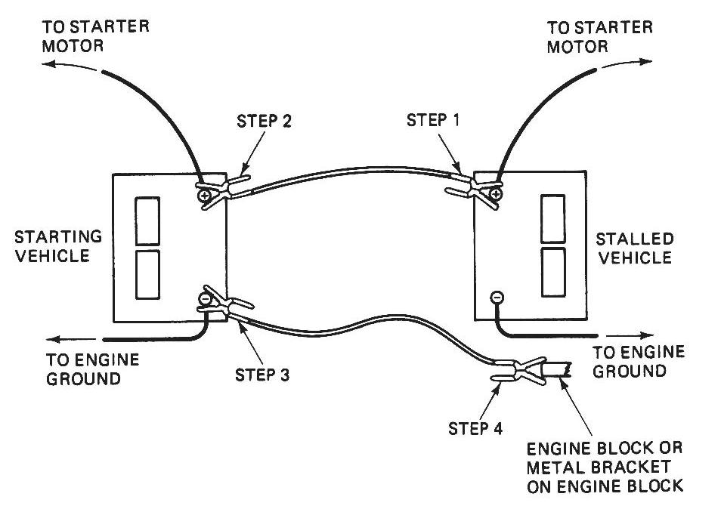
5. Allow the good vehicle to run for
several minutes to charge the battery
of the disabled vehicle.

6. Start the disabled vehicle.

7. After the engine is running smoothly,
disconnect the black cable from the
engine ground of the disabled vehicle
and then disconnect the negative
terminal of the battery of the good
vehicle.

8. Disconnect the red battery cable ends from the positive terminals of the batteries.

