Meets ASE Task: (A6-B-5) P-1 Perform battery charging according to manufacturer’s recommendations.

Name:_____________________________________
Date:_____________
Time on Task:_____________
Make/Model/Year:____________________________________
VIN:_________________________________
Evaluation (Enter number from 4, 3, 2, 1) :_________
Battery Charging
Page 149
1. Measure the open-circuit voltage of the battery = ______ volts (red lead of the
voltmeter to positive [+] and black lead to negative [-]). (If more than 12.6 V, remove
the surface charge by turning on the headlights for 1 minute).
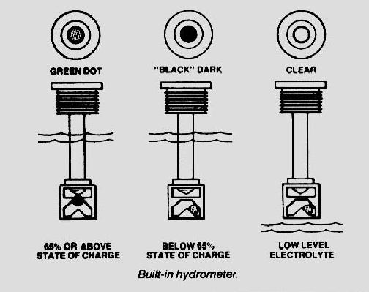

2. Percentage of charge = ______%.

12.6 V or higher = 100% charged
12.4 V = 75% charged
12.2 V = 50% charged
12.0 V = 25% charged
below 11.9 V = discharged

3. Determine the cold cranking amperes
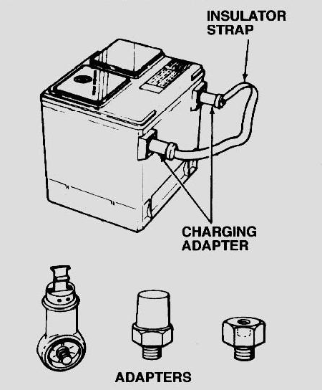
(CCA) of the battery = __________.

(The charge rate should be 1% of the CCA. For example, a battery with a 500 CCA rating should be charged at 5 ampere rate.) Charge Rate = CCA
100
4. Determine the reserve capacity in minutes = _________.

(The charge rate can be determined by dividing the reserve capacity of the battery in minutes by 30. For example, a 180-minute battery should be charged at 6 ampere rate: 180/30 = 6).

Charge Rate = Reserve Capacity
30

5. The battery should be charged at _____ amperes
(CCA method) or at _____ amperes (reserve capacity method).

