Meets ASE Task: (A6-B-4) P-1 Inspect and clean battery; fill battery cells (if applicable); check battery cables, connectors, clamps, and hold-downs.
Name:_____________________________________
Date:_____________
Time on Task:_____________
Make/Model/Year:____________________________________
VIN:_________________________________
Evaluation (Enter number from 4, 3, 2, 1) :_________
Service and Replace the Battery
Page 148
1. Check service information for the specified procedures to follow to inspect, clean, fill,
and replace a battery.
__________________________________________________________________
__________________________________________________________________
2. Check all that apply:
Battery hold-down clamps/brackets are in place
Filler cap(s) is removable
Battery electrolyte cannot be checked
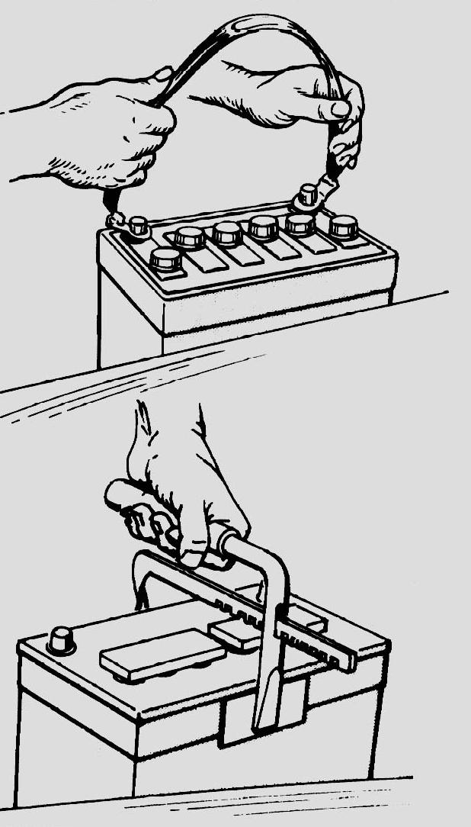
Electrolyte level is low
Corrosion was found on battery terminals/cable ends
Other faults or conditions (describe)
_______________________________
_______________________________

3. Clean the battery.

4. Clean the battery cables and cable ends.

5. Remove and install the battery.

