Meets ASE Task: (A6-B-1) P-1 Perform battery state-of-charge test; determine needed action. (A6-B-2) P-1 Confirm proper battery capacity for vehicle application; perform battery capacity and load test; determine needed action.
Name:_____________________________________
Date:_____________
Time on Task:_____________
Make/Model/Year:____________________________________
VIN:_________________________________
Evaluation (Enter number from 4, 3, 2, 1) :_________
Battery and Capacity Tests
Page 146
1. Check service information for the specified method for determining the state-of-
charge of the battery.

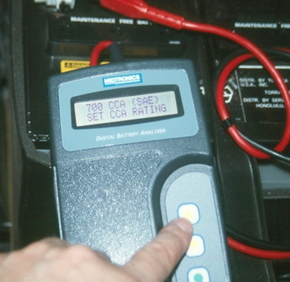
_____________________________________________________
_____________________________________________________
_____________________________________________________
2. Determine the state-of-charge using a voltmeter.
12.6 volts or higher = 100% charged
12.4 volts = 75% charged
12.2 volts = 50% charged
12.0 volts = 25% charged
10.5 volts = dead
3. Determine the state-of-charge and capacity using a conductance tester.
__________________________________________

4. Determine the capacity of the battery using a carbon pile tester.
__________________________________________

5. What is the condition of the battery? ______________________________________

6. What is the needed action? _____________________________________________
__________________________________________________________________

