Meets ASE Task: (A6-B-2) P-1 Confirm proper battery capacity for vehicle application; perform battery capacity and load test; determine needed action.
Name:_____________________________________
Date:_____________
Time on Task:_____________
Make/Model/Year:____________________________________
VIN:_________________________________
Evaluation (Enter number from 4, 3, 2, 1) :_________
Battery Specifications
Page 144
1. Determine the following information about the battery.
A. Cold cranking amperes (CCA) rating = ______ (usually 500-1000)
B. Cranking amperes (CA) rating = ______ (usually 500-1000)
C. Reserve capacity rating (in minutes) = ______ (usually 50-200)
2. What are the recommended load test amperes?
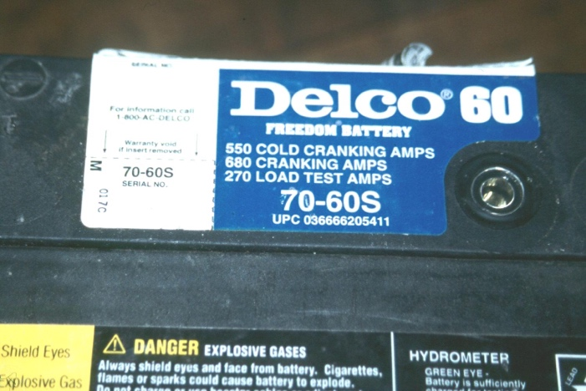
_______ A (normally 1/2 of CCA rating)
3. Size of the battery:
Height = __________
Length = __________
Width = __________
4. Type of terminals:
Side terminals
Top terminals
Both side and top terminals
5. Determine the age of the battery from the shipping date sticker or other codes.
Sticker = ______________________
Less than 1 year old
1 to 3 years old
3 to 5 years old
Older than 5 years
Unknown

