Meets ASE Task: (A6-G-8) P-1 Diagnose body electronic systems circuits using a scan tool; check for module communication errors (data bus systems); determine needed action.
Name:_____________________________________
Date:_____________
Time on Task:_____________
Make/Model/Year:____________________________________
VIN:_________________________________
Evaluation (Enter number from 4, 3, 2, 1) :_________
Module Communication
Page 143
1. Check service information for the specified method and procedures to follow to check
for proper module communications.
_________________________________________________________________
_________________________________________________________________
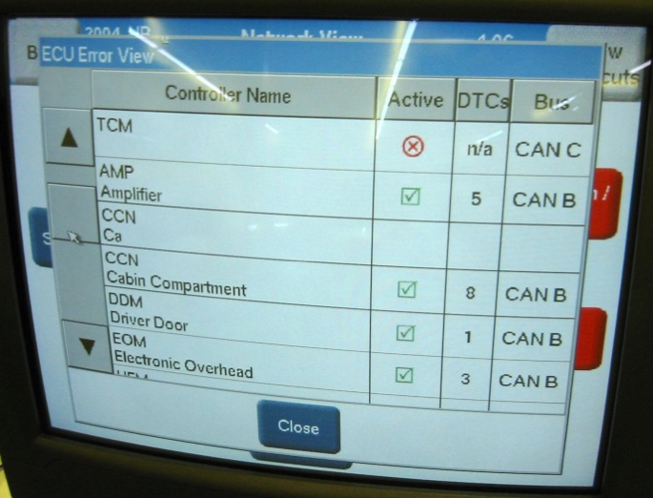
2. Check all that apply:

Use a factory scan tool.

Use a global OBD-II scan tool.

Use a DMM to check for resistance
on communication circuits.

Use a fused jumper wire and a scan
tool to diagnose communication
errors.

Other (describe) ________________________________________________

3. List the modules that are preset in the vehicle being tested.

a. _________________________ f. _________________________
b. _________________________ g. _________________________
c. _________________________ h. _________________________
d. _________________________ j. _________________________
e. _________________________ k. _________________________

4. Based on the test results, what is the needed action? _______________________

________________________________________________________________

