Meets ASE Task: (Not specified by ASE)
Name:_____________________________________
Date:_____________
Time on Task:_____________
Make/Model/Year:____________________________________
VIN:_________________________________
Evaluation (Enter number from 4, 3, 2, 1) :_________
Electronic Fundamentals
Page 142
1. Describe the difference between a zener diode and a clamping diode. _____________
__________________________________________________________________
__________________________________________________________________

2. Describe the operation of a photo resistor. ___________________________________
__________________________________________________________________
__________________________________________________________________

3. What is meant by the term “negative coefficient thermistor?” ____________________
__________________________________________________________________
__________________________________________________________________
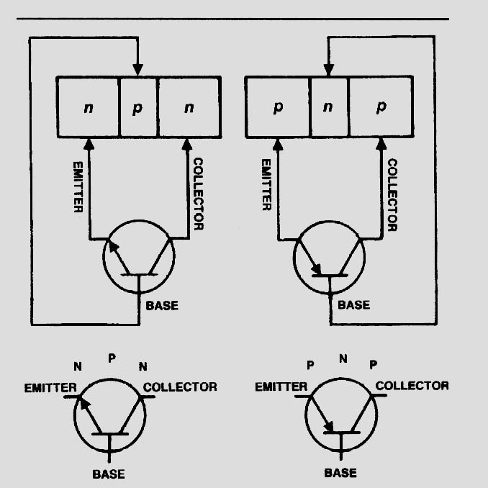
4. What is the difference between a PNP and a NPN
transistor?
____________________________________
____________________________________
____________________________________
____________________________________

5. List three precautions that service technicians should
do to help prevent damage to electronic components from ESD.
a. _________________________________________
b. _________________________________________
c. _________________________________________

