Meets ASE Task: (A6-A-12) P-1 Inspect, test, repair, and/or replace components, connectors, terminals, harnesses, and wiring in electrical/electronic systems (including solder repairs).
Name:_____________________________________
Date:_____________
Time on Task:_____________
Make/Model/Year:____________________________________
VIN:_________________________________
Evaluation (Enter number from 4, 3, 2, 1) :_________
Inspect and Test Relays
Page 141
1. Check service information for the specified procedures for inspecting and testing
relays.
__________________________________________________________________
__________________________________________________________________

2. Relays should “click” when actuated. List all the relays and determine if they click
by listening or feeling the relay housing.
Circuit or Relay ID Clicks? Yes or No
_____________________________________ _______
_____________________________________ _______
_____________________________________ _______
_____________________________________ _______
_____________________________________ _______
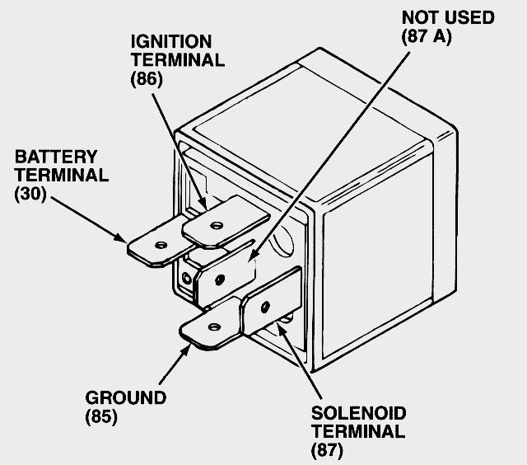
_____________________________________ _______

3. How many four-terminal relays are used? ____________

4. How many five-terminal relays are used? ____________

5. Test a relay for proper operation using an ohmmeter:

Coil resistance (usually labeled terminals 86 and 85)
= ________ (usually between 60 and 100 ohms).

Continuity normally closed (NC) contact (usually labeled terminals 30 and 87)
= ________ (should be close to zero ohms).

6. Based on the inspections and tests, what is the needed action? _________________

_____________________________________________________________________

