Caution: Proper operation of an oxy-acetylene torch requires proper instruction and willingness to follow all safety precautions.
Evaluation (Enter number from 4, 3, 2, 1) :_________

Meets ASE Task: (Not specified by ASE)
Oxy-Acetylene Torch Usage

Name:_____________________________________
Date:_____________
Time on Task:_____________
Make/Model/Year:____________________________________
VIN:_________________________________
Page 14
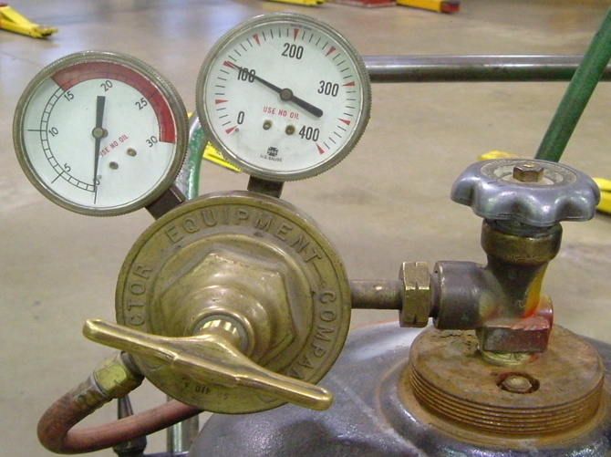
Instructor: Check that proper instruction has been given on the safe use of the oxy-acetylene torch.

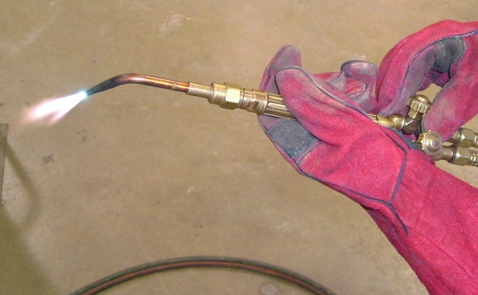
1. Setup the torch and pressures to heat metal.

Oxygen pressure set to __________

Acetylene pressure set to _________

Instructor’s OK _________________

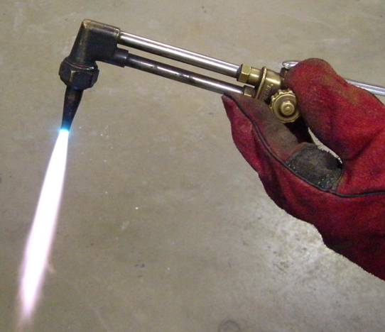
2. Setup torch to cut metal.

Oxygen pressure set to _________

Acetylene pressure set to _________

Instructor’s OK _________________

