Meets ASE Task: (A6-A-6) P-1 Demonstrate knowledge of the causes and effects from shorts, grounds, opens, and resistance problems in electrical/electronic circuits.
Name:_____________________________________
Date:_____________
Time on Task:_____________
Make/Model/Year:____________________________________
VIN:_________________________________
Evaluation (Enter number from 4, 3, 2, 1) :_________
Locate Shorts, Grounds, and Opens
Page 139
1. Check service information for the recommended method for locating shorts, grounds,
and opens.
__________________________________________________________________
__________________________________________________________________

2. Follow the recommended troubleshooting procedure to
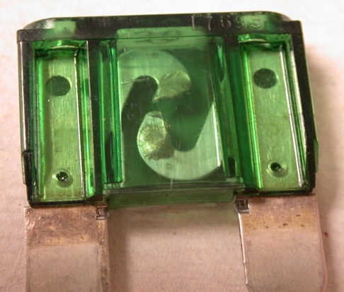
locate the short-to-ground. Check all that apply.
Short finder
Ohmmeter attached to the fuse panel with the
fuse removed
Voltmeter attached to the fuse panel with the fuse
removed
Ammeter attached to the fuse panel with the fuse removed
Sonic short finder
Other (describe) __________________________________

3. Most diagnostic test procedures include checking for proper power and ground at the
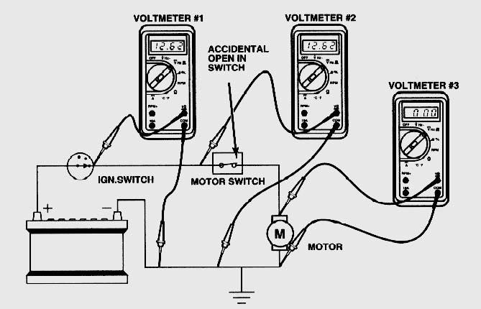
component that is not functioning.

a. Is there voltage at the
component when the circuit is
activated?
Yes No

b. Is there continuity between the
ground connection at the
component and a good chassis
ground?
Yes No

4. Based on the test results, what is the needed action? ________________________

