Meets ASE Task: (A6-A-9) P-1 Use wiring diagrams during the diagnosis of electrical/electronic circuit problems.
Name:_____________________________________
Date:_____________
Time on Task:_____________
Make/Model/Year:____________________________________
VIN:_________________________________
Evaluation (Enter number from 4, 3, 2, 1) :_________
Diagnose Electrical/Electronic Circuits
Page 138
1. Check service information to determine the specified diagnosis procedures to follow
for a slowly operating wiper motor. This circuit is a ________ circuit.

Series
Parallel
Series-Parallel

2. One taillight is dim, all other exterior lighting operates normally. Check service
information to determine the specified diagnostic procedure to follow for a dim
taillight.

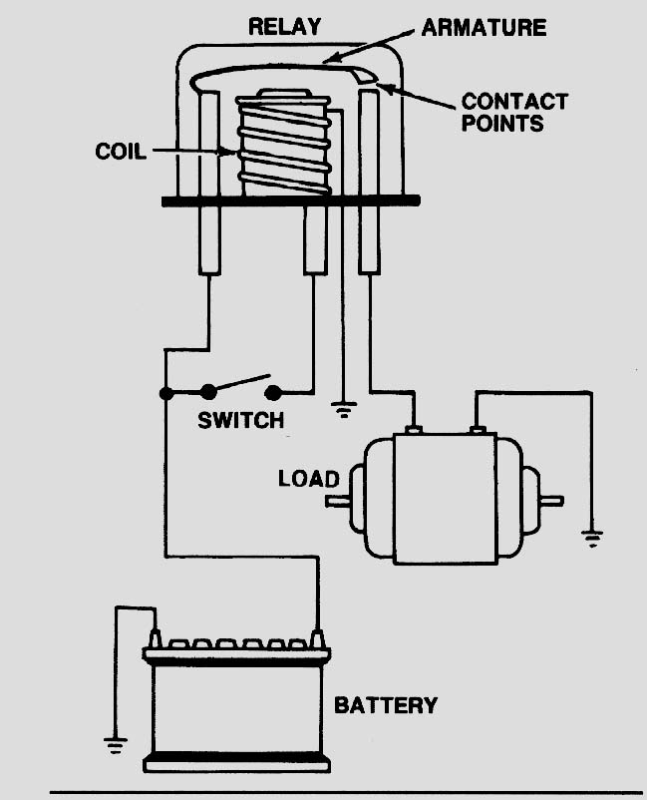
This circuit is a ________ circuit.

Series
Parallel
Series-Parallel

3. Check service information to determine the
specified diagnostic procedure to follow to
correctly diagnose a fault in a blower motor
circuit.

_________________________________
_________________________________
_________________________________
_________________________________

