Meets ASE Task: (A6-A-12) P-1 Inspect, test, repair, and/or replace components, connectors, terminals, harnesses, and wiring in electrical/electronic systems (including solder repairs).
Name:_____________________________________
Date:_____________
Time on Task:_____________
Make/Model/Year:____________________________________
VIN:_________________________________
Evaluation (Enter number from 4, 3, 2, 1) :_________
Solder Wire Repair
Page 136
1. Check service information for the specified procedures to follow when performing a
solder wire repair.

__________________________________________________________________
__________________________________________________________________
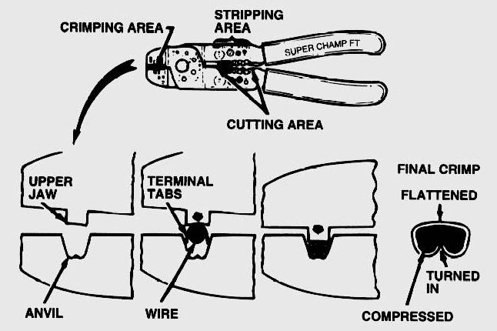

2. Does the vehicle manufacturer specify
that all hand-crimped terminals be
soldered?

Yes No

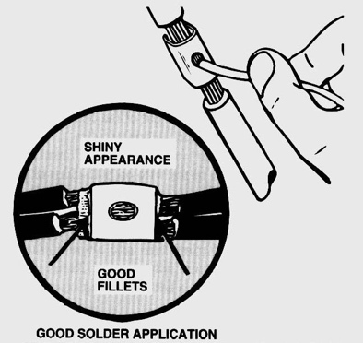
3. Does the vehicle manufacturer specify the use of
wire clips when soldering two wires together?

____ Yes ____ No

4. Check all that apply:

Wire repair is to be covered with splice tape.
Wire repair is to be covered with heat-shrink tubing.
Wire repair is to be covered with adhesive-lined heat shrink tubing.
Other (describe) _______________________________________________

