Meets ASE Task: (A6-A-12) P-1 Inspect, test, repair, and/or replace components, connectors, terminals, harnesses, and wiring in electrical/electronic systems (including solder repairs).
Name:_____________________________________
Date:_____________
Time on Task:_____________
Make/Model/Year:____________________________________
VIN:_________________________________
Evaluation (Enter number from 4, 3, 2, 1) :_________
Wire Harness and Connector Repair
Page 135
1. Check service information for the specified procedures for repairing wiring harnesses
and connectors. Describe:
__________________________________________________________________
__________________________________________________________________
2. Perform a visual inspection and determine the following information regarding the
wiring harnesses in the vehicle.
a. Is the wiring harness covered with corrugated plastic conduit?
Yes No (If no, disregard “B”.)

b. Does the plastic corrugated conduit have a green or gray painted stripe?
Yes No
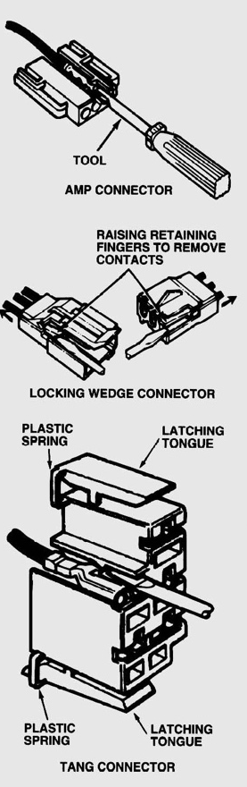
NOTE: The green or gray painted stripe indicates
that the conduit is designed to withstand high
temperatures up to about 300°F (150°C).

c. Is the wiring harness routed near any of these items?
A heat source such as an EGR valve?
Yes No
Close to moving components?
Yes No

3. Are the electrical connectors weather-proof?
Yes No
