**Meets ASE Task:** (A6-A-12) P-1 Inspect, test, repair, and/or replace components, connectors, terminals, harnesses, and wiring in electrical/electronic systems (including solder repairs).

Name:_____________________________________

Date:_____________

Time on Task:_____________

Make/Model/Year:____________________________________

VIN:_________________________________

Evaluation (Enter number from 4, 3, 2, 1) :_________

**Inspect Wiring and Connectors**

Page 134

**1.** Check service information for the specified procedures for inspecting and testing

wires and connectors.

__________________________________________________________________

__________________________________________________________________

**2.** Most service information recommends that all wiring and connectors be inspected

visually, especially where wiring is routed near sources of heat or where wiring is

subject to movement. Perform a thorough visual inspection of all wires and

connectors and note any faults.

**Wire or Connector Fault(s) Location (describe)**

___________________________________ ___________________________

___________________________________ ___________________________

___________________________________ ___________________________

___________________________________ ___________________________

**3.** 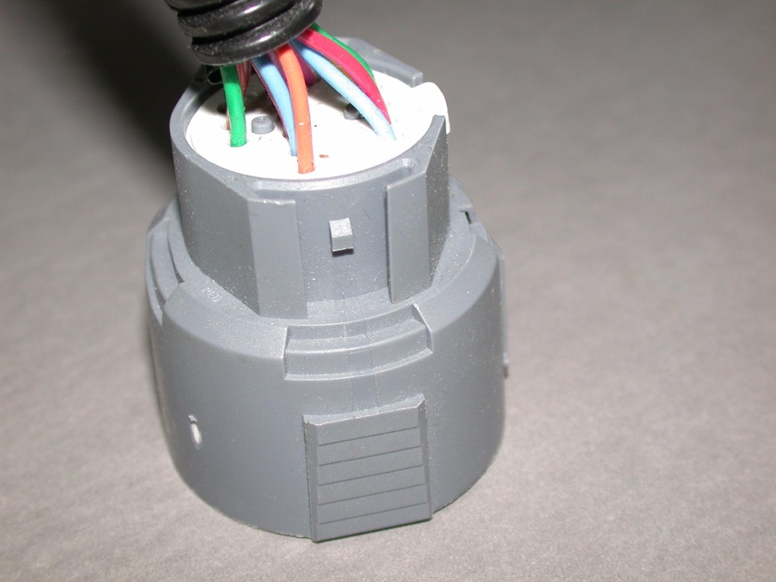List the tools needed to separate the terminals from

the connectors:

a. _______________________________

b. _______________________________

c. _______________________________

**4.** Based on your inspection and testing,

what is the needed action?

______________________________

______________________________

______________________________