Meets ASE Task: (A6-A-13) P-1 Test and measure circuit using an oscilloscope and/or graphing multimeter (GMM); interpret results; determine needed action. (A8-B-7) P-1 Inspect and test computerized engine control system sensors, powertrain/engine control module (PCM/ECM), actuators, and circuits using a graphing multimeter (GMM), digital storage oscilloscope (DSO), and/or scan tool; determine needed action.
Name:_____________________________________
Date:_____________
Time on Task:_____________
Make/Model/Year:____________________________________
VIN:_________________________________
Evaluation (Enter number from 4, 3, 2, 1) :_________
Oscilloscope

Page 132
1. Check service information for the recommended usage of an oscilloscope to diagnose
electrical or electronic concerns. Describe the tests recommended. _______________
__________________________________________________________________
__________________________________________________________________
2. According to service information, which system can/should be tested using an
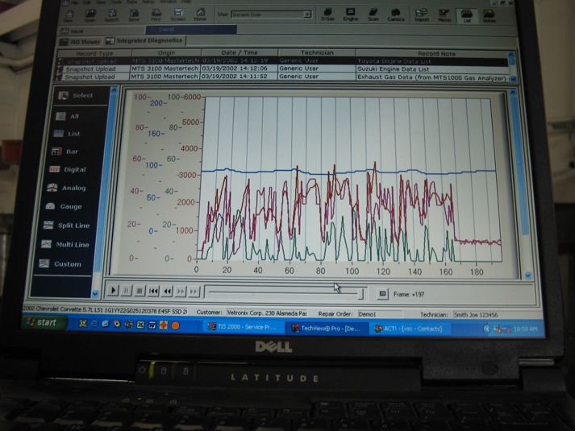
oscilloscope? (Check all that apply.)
Wheel speed sensor
Crankshaft position sensor
Camshaft position sensor
Secondary ignition
Serial data communication circuits
Audio circuits
Other (describe) ______________
____________________________
3. Which system(s) was tested using an oscilloscope? ___________________________
_________________________________________________________________
_________________________________________________________________
4. Based on the test results, what is the needed action? __________________________
_________________________________________________________________
_________________________________________________________________
_________________________________________________________________

