Meets ASE Task: (A6-A-8) P-1 Use fused jumper wires to check operation of electrical circuits per service information.
Name:_____________________________________
Date:_____________
Time on Task:_____________
Make/Model/Year:____________________________________
VIN:_________________________________
Evaluation (Enter number from 4, 3, 2, 1) :_________
Circuit Testing Using a Fused Jumper Wire

Page 131
CAUTION: A fused jumper wire should never be used to bypass an electrical load device. A fused jumper wire should only be used to bypass circuit control devices such as switches or relays.

1. Check service information for a diagnostic test procedure that includes the use of a
fused jumper wire.

__________________________________________________________________

__________________________________________________________________

__________________________________________________________________

2. A horn circuit is a commonly used circuit to show the use of a fused jumper wire.

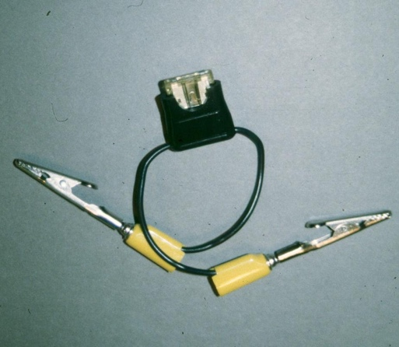
a. Locate the horn (describe the location):

_______________________________

b. Disconnect the wire from the horn.

c. Connect one end of the fused jumper wire
to the terminal of the horn.

d. Touch the other end of the fused jumper
wire to the positive (+) terminal of the
battery.

e. The horn should work. OK NOT OK

3. Based on the test results, what is the needed action? __________________________

__________________________________________________________________

