1. Check the power and shop equipment in the shop, at a local shop, or dealer. Where
Meets ASE Task: (A0-B-1) Identify tools and their usage in automotive applications.
Power and Shop Equipment Safety Survey

Name:_____________________________________
Date:_____________
Time on Task:_____________
Make/Model/Year:____________________________________
VIN:_________________________________
Evaluation (Enter number from 4, 3, 2, 1) :_________
Page 13
was this survey taken? ________________________________________________
_______________________________
2. List all shop equipment, such as hoists, floor jacks, and cranes, and not whether they
are equipped with all needed safety devices.
Shop Equipment Safety devices? If not, list:
_____________________________ Yes No (describe) ________________
_____________________________ Yes No (describe) ________________
_____________________________ Yes No (describe) ________________
_____________________________ Yes No (describe) ________________
_____________________________ Yes No (describe) ________________
_____________________________ Yes No (describe) ________________

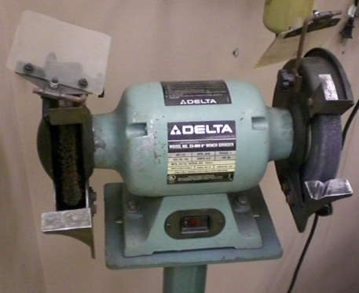
3. List all power equipment, such as trouble
lights, grinders, etc. and note whether they
are equipped with all needed safety devices.

Power Equipment Safety devices? If not, list:
_____________________________ Yes No (describe) ________________
_____________________________ Yes No (describe) ________________
_____________________________ Yes No (describe) ________________
_____________________________ Yes No (describe) ________________
_____________________________ Yes No (describe) ________________

