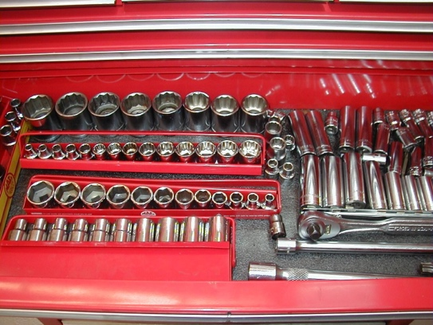
1. List the sizes of wrenches you have in
Meets ASE Task: (A0-B-1) Identify tools and their usage in automotive applications.
Hand Tool Identification

Name:_____________________________________
Date:_____________
Time on Task:_____________
Make/Model/Year:____________________________________
VIN:_________________________________
Evaluation (Enter number from 4, 3, 2, 1) :_________
Page 12
your toolbox. ______________________
_______________________________
_______________________________
What sizes are missing or will need to be
purchased? _________________________
_______________________________
2. List the sizes of the 1/4 inch drive sockets you have in your toolbox. _____________
__________________________________________________________________
What sizes are missing or will need to be purchased? __________________________
_________________________________________
3. List the sizes of the 3/8 inch drive sockets you have in your toolbox. _____________
__________________________________________________________________
What sizes are missing or will need to be purchased? __________________________
__________________________________________________________________
4. List the sizes of the 1/2 inch drive sockets you have in your toolbox. ____________
__________________________________________________________________
What sizes are missing or will need to be purchased? __________________________
__________________________________________________________________
5. List the other tools you have in your toolbox including hammers, screwdrivers,
pliers, and other items. __________________________________________________
__________________________________________________________________
List additional tools that you wish to add to your toolbox. ______________________
__________________________________________________________________

