Meets ASE Task: (A1-C-15) P-1 Assemble engine block.

Evaluation (Enter number from 4, 3, 2, 1) :_________
Engine Assembly
Name:_____________________________________
Date:_____________
Time on Task:_____________
Make/Model/Year:____________________________________
VIN:_________________________________
Page 116
1. Check service information for the specified procedures and torque specifications for
the engine being assembled.
A. Specified procedures: ____________________________________________
___________________________________________________________
___________________________________________________________
B. Specified torque specifications: _____________________________________
____________________________________________________________
____________________________________________________________
____________________________________________________________
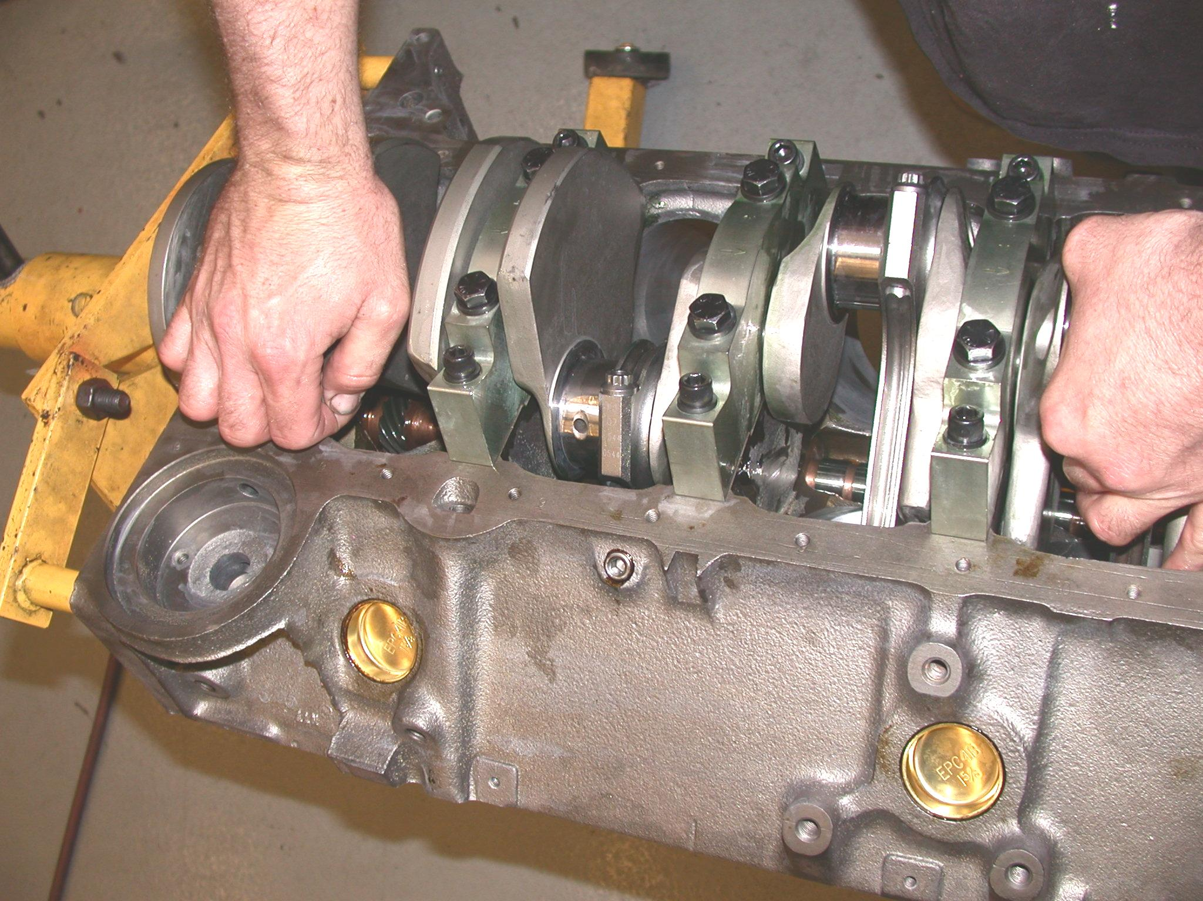

2. Install the engine block cups and plugs. Instructor check off _____
3. Assemble pistons and rotating assembly. Instructor check off _____
4. Assemble cylinder heads and camshaft. Instructor check off _____
5. Finish assembly. Instructor check off _____

